5.13 Cucumber Integration with Extent Report



This section will guide you to:

Setup Cucumber eclipse plugin, Maven project set up, and Extent report set up

**Development Environment:**

* JRE: OpenJDK Runtime Environment 11.0.2
* Eclipse IDE for Enterprise Java Developers v2019-03 (4.11.0)
* TestNG
* Selenium jars
* Cucumber jars

This guide has two subsections, namely:

5.13.1 Integrating Cucumber extent report

5.13.2 Pushing code to your GitHub repositories

**Step 5.13.1:** IntegratingCucumber with Extent Report

* In POM.Xml please add below maven dependencies.

|  |
| --- |
| <dependency>  <groupId>com.aventstack</groupId>  <artifactId>extentreports</artifactId>  <version>3.0.6</version>  </dependency>  <dependency>  <groupId>com.vimalselvam</groupId>  <artifactId>cucumber-extentsreport</artifactId>  <version>3.0.2</version> |

* Add ***extent-config.xml*** *file under test/resources in your maven project.*



* *And add below code inside it.*

|  |
| --- |
| ***<?xml version="1.0" encoding="UTF-8"?>***  ***<extentreports>***  ***<configuration>***  ***<!-- report theme -->***  ***<!-- standard, dark -->***  ***<theme>standard</theme>***    ***<!-- document encoding -->***  ***<!-- defaults to UTF-8 -->***  ***<encoding>UTF-8</encoding>***    ***<!-- protocol for script and stylesheets -->***  ***<!-- defaults to https -->***  ***<protocol>https</protocol>***    ***<!-- title of the document -->***  ***<documentTitle>ExtentReports 2.0</documentTitle>***    ***<!-- report name - displayed at top-nav -->***  ***<reportName></reportName>***    ***<!-- report headline - displayed at top-nav, after reportHeadline -->***  ***<reportHeadline>Automation Report</reportHeadline>***    ***<!-- global date format override -->***  ***<!-- defaults to yyyy-MM-dd -->***  ***<dateFormat>yyyy-MM-dd</dateFormat>***    ***<!-- global time format override -->***  ***<!-- defaults to HH:mm:ss -->***  ***<timeFormat>HH:mm:ss</timeFormat>***    ***<!-- custom javascript -->***  ***<scripts>***  ***<![CDATA[***  ***$(document).ready(function() {***    ***});***  ***]]>***  ***</scripts>***    ***<!-- custom styles -->***  ***<styles>***  ***<![CDATA[***    ***]]>***  ***</styles>***  ***</configuration>***  ***</extentreports>*** |

* In the Runner File under plugin add below code.

|  |
| --- |
| Plugin={“com.cucumber.listener.ExtentCucumberFormatter:target/html/ExtentReport.html “} |

* Also add below code in After class of runner file.

|  |
| --- |
| public class TestRunner  {  @AfterClass  public **static** **void** setup()  {  Reporter.loadXMLConfig(new File("src/test/resources/extent-config.xml"));  Reporter.setSystemInfo("User Name", "AJ");  Reporter.setSystemInfo("Application Name", "Test App ");  Reporter.setSystemInfo("Operating System Type", System.getProperty("os.name").toString());  Reporter.setSystemInfo("Environment", "Production");  Reporter.setTestRunnerOutput("Test Execution Cucumber Report");  }  } |

Now, after executing the code extent report would be generated inside /target/html folder and it would be looking something like this

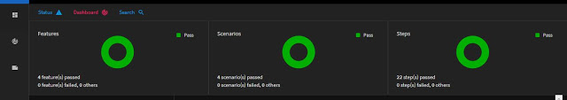

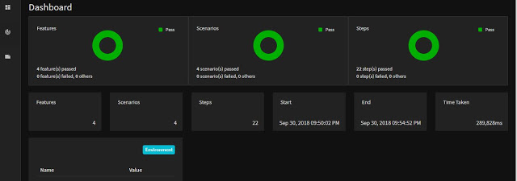

**Step 5.13.2:** Pushing code to GitHub repositories

Open your command prompt and navigate to the folder where you have created your files

cd <folder path>

Initialize your repository using the following command:

git init

Add all the files to your git repository using the following command:

git add . 

Commit the changes using the following command:

git commit . -m “Changes have been committed.”

Push the files to the folder you initially created using the following command:

git push -u origin master